ASSIGNMENT 8-Collaborative Filtering

Mahima V PES1201700665

Amrita hegde PES1201700970

Chaitra H P PES1201701370

Problem Statement:

Use collaborative filtering to recommend

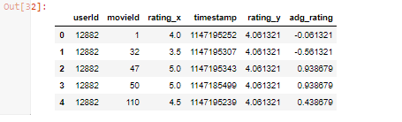

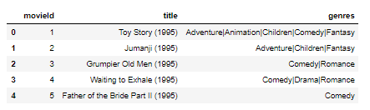

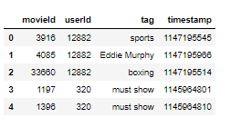

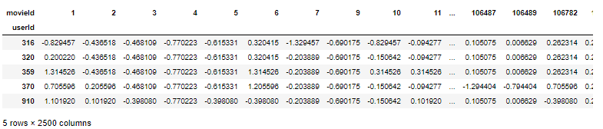

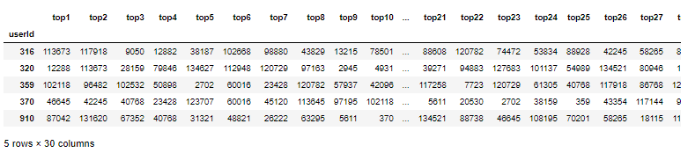

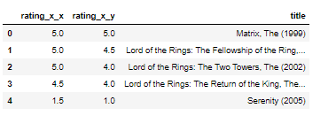

score (u,i) is 4.255766437391595

